**Palawan Council for Sustainable Development Staff:**

**Human Resource Information System (HRIS)**

**User Manual**

Version 1.0

06/26/2019

Table of Contents

1. Introduction 1

2. Overview 2

3. Getting Started 3

3.1 Set-up Considerations 3

3.2 User Access Considerations 3

3.3 Accessing the System 3

3.4 System Organization & Navigation 4

3.5 Exiting the System 4

4. Using the System 5-11

5. Error Message 12

Appendix A: Glossary 13

## Introduction

The Human Resource Information System (HRIS) is a computerized information package for recording, storing, manipulating and communicating information of every staff of the agency. It provides data for purposes of control and decision making and it is a part of the organizations/agency’s larger management information system

**CHARACTERISTICS OF THE HRIS**

* Produces total information systems (integrated reports, letters, memoranda and electronic data)
* Linked to electronic data processing facilities for ease of access, updating and analysis
* Information is gathered, analyzed and presented in the form desired by decision makers in the organization
* Provides current/accurate data for control and decision making
* Produce reports, forecast human resources (HR) needs, strategic planning, career and promotion planning & evaluating HR policies and practices

This manual guides in the computer-based information system that the Human Resource personel shall use to input data thru electronic virtual database.

**Uses of this system:**

* Track information and maintain employee records
* Handle absence and vacation records
* Administer recruitment and training programs
* Optimize file management and storage for every personnels/employees

## Overview

HRIS a web-based system or tool, which allows collecting data/information about the agency’s employees and personnel. The web based tool provides electronic version of the form used in gathering information. The tool saves data collected to database. HRIS has capabilities to run on any major cross platforms interface including Windows, Mac, Linux and Android (soon).

## Getting Started

This section provides a general walkthrough of the system from initiation through exit.

### Set-up Considerations

**Supported Operating Systems**

* Windows Operation system such as XP to Windows 10
* Mac OS El Capitan to High Sierra
* Linux Distros such as Ubuntu, Kali, Deepin, Mint etc.
* Android 4.4 ++ (App support soon).

**Hardware**

* Computer Desktop or laptop.
* 1.8 GHz or faster processor. Dual-core or better recommended
* 2 GB of RAM; 4 GB of RAM recommended (2.5 GB minimum if running on a virtual machine)

**Supporter Language**

* English

### User Access Considerations

User level have 3 Types: *Admin and User.*

* ***Admin*** have all the access in the information system such as creating new account, changing other account’s user level, deleting accounts and viewing the account list (*settings*).
* ***User*** can only update and view their account to My Account feature in (*settings*).

### Accessing the System

User must have his account username and password. The admin account will immediately be given to the designated personnel upon installation of the Information System.

Account will only be created upon request to the admin.

### Dashboard & Navigation (Main Menu)

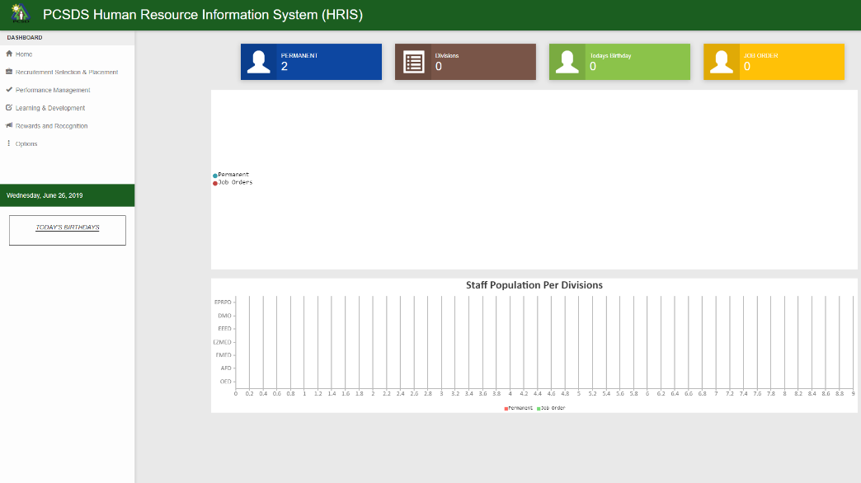

**Dashboard contains the following main core functions:**

* 1. **Recruitment Selection & Placement (** Refer to 4:3.1**)**
  2. **Performance Monitoring (** Refer to 4:3.2**)**
  3. **Learning & Development (** Refer to 4:3.3**)**
  4. **Rewards and Recognition (** Refer to 4:3.4**)**

**Log out** – exit from the system.

### Exiting the System

Log out button informs the Information System that the current user wishes to end the login session.

## Using the System

**1.0 LogIn Form**

Click after completing username and password

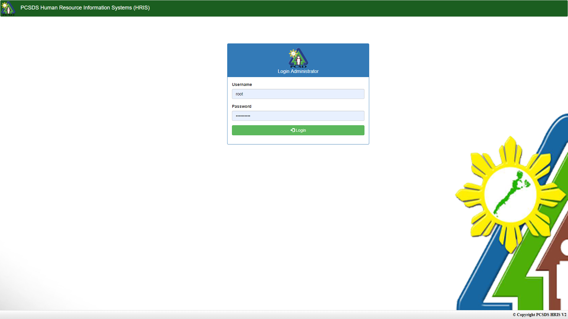

User will enter account password

User will enter account username

* Clicking LOGIN button, the Home Page Screen will display if username and password are valid.
* Upon logging, you can change the password or username for the acount by clicking the setting button.
* To request for a new account, user must send request message.

Add button for Adding new Personnel Info.

Refer to page 8 Form1.1

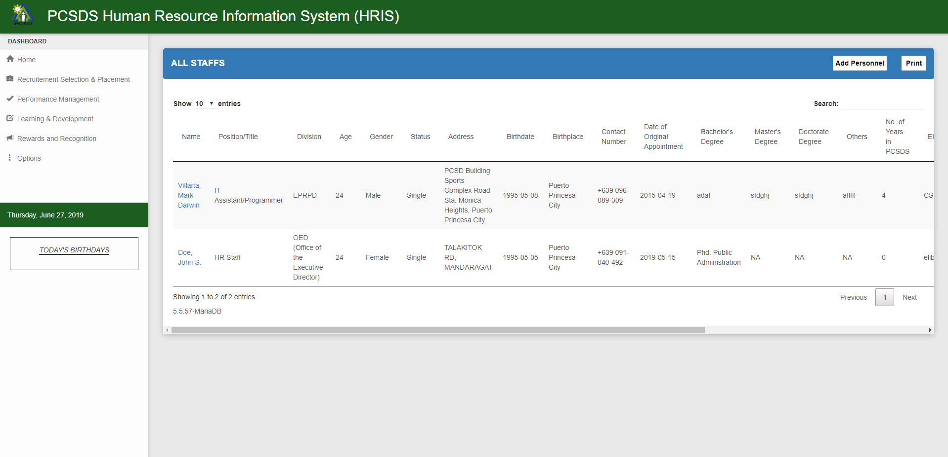**2.0 Home page (Admin and User)**

DataGrid screen that display information added

Search bar for searching data.

Clicking the Add New Button will display fill-up form

**3.0 Settings (Admin and User)**

Sidebar Notification for current Date and Birthdays in current day

Sidebar Navigation for Core and sub functions of the IS

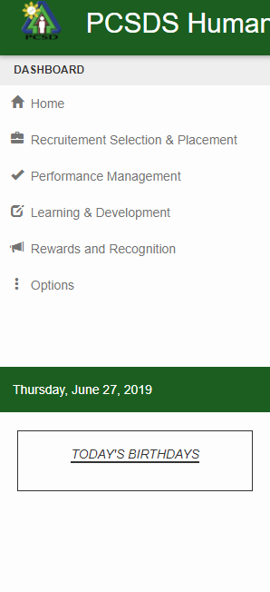

**CORE FUNCTIONS**

**3.1 Recruitment Selection & Placement**

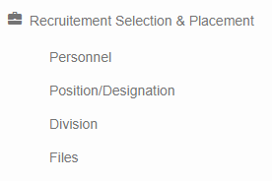

* A core function for Adding Information about the employee or personnel.
* Used for Adding Position/Designation and Division, adding it will be available at the fill up form.
* Used for Uploading Files Repository for each employee or personnel that will be added to the IS

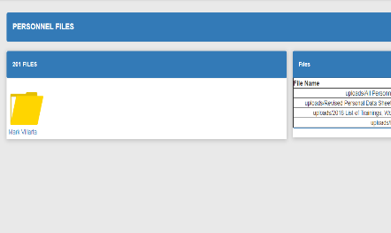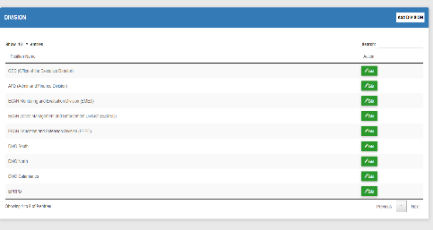

File Upload Form and Data Grid

Position/Designation Data Grid and Add Form

**3.2 Performance Management**

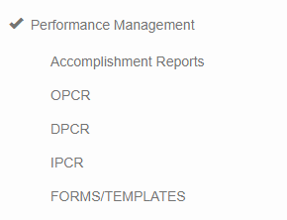

* A core function File Repository of each personnel’s Accomplishment Reports, OPCR, DPCR and IPCR
* Each menu also has a downloadable Templates for the files.

**3.3 Learning & Development**

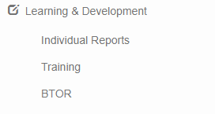

* A core function for Individual reporting via file uploads like document files , trainings and BTOR files and etc.

**3.4 Rewards & Recognition**

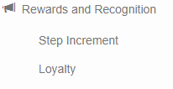

* A core function for every employee / personnel’s step Increments and loyalty information via notification and data listings

**4.0 Forms , Reporting and Print Outs**

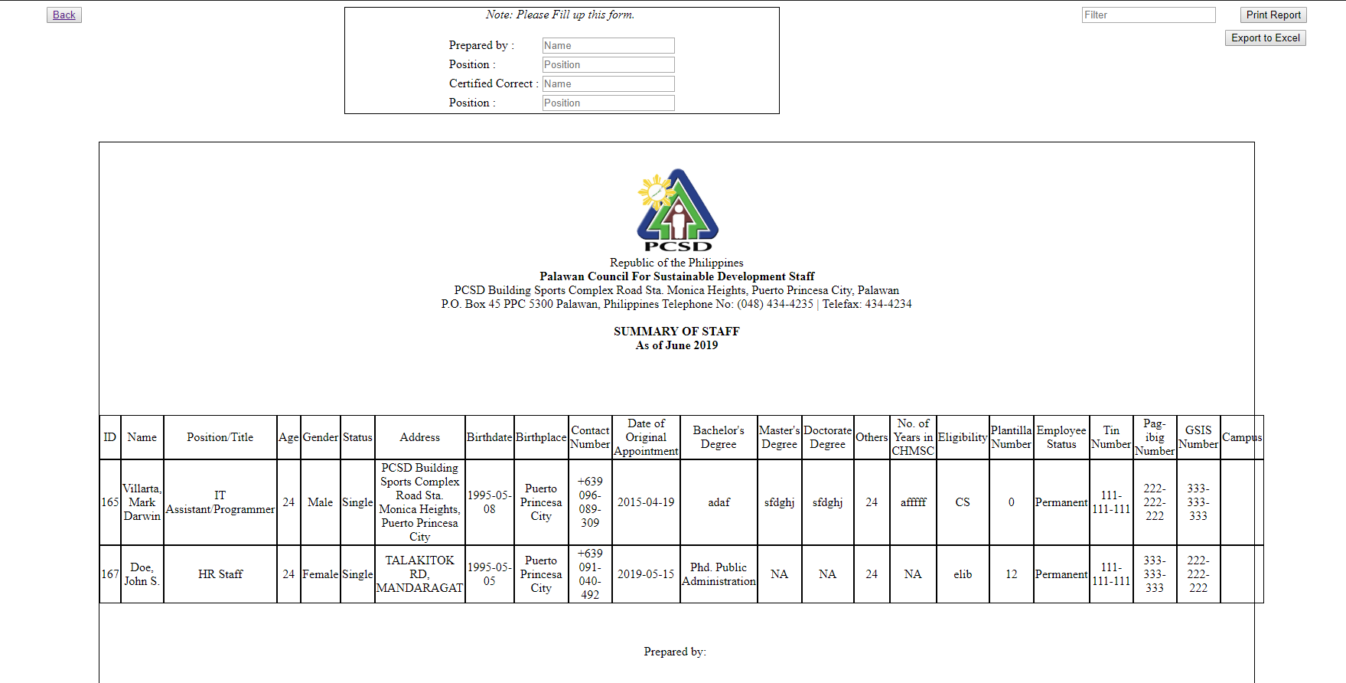

Export the report to excel file

* This will view the summary of information’s of all employee/ personnel.

Print Report directly to printer

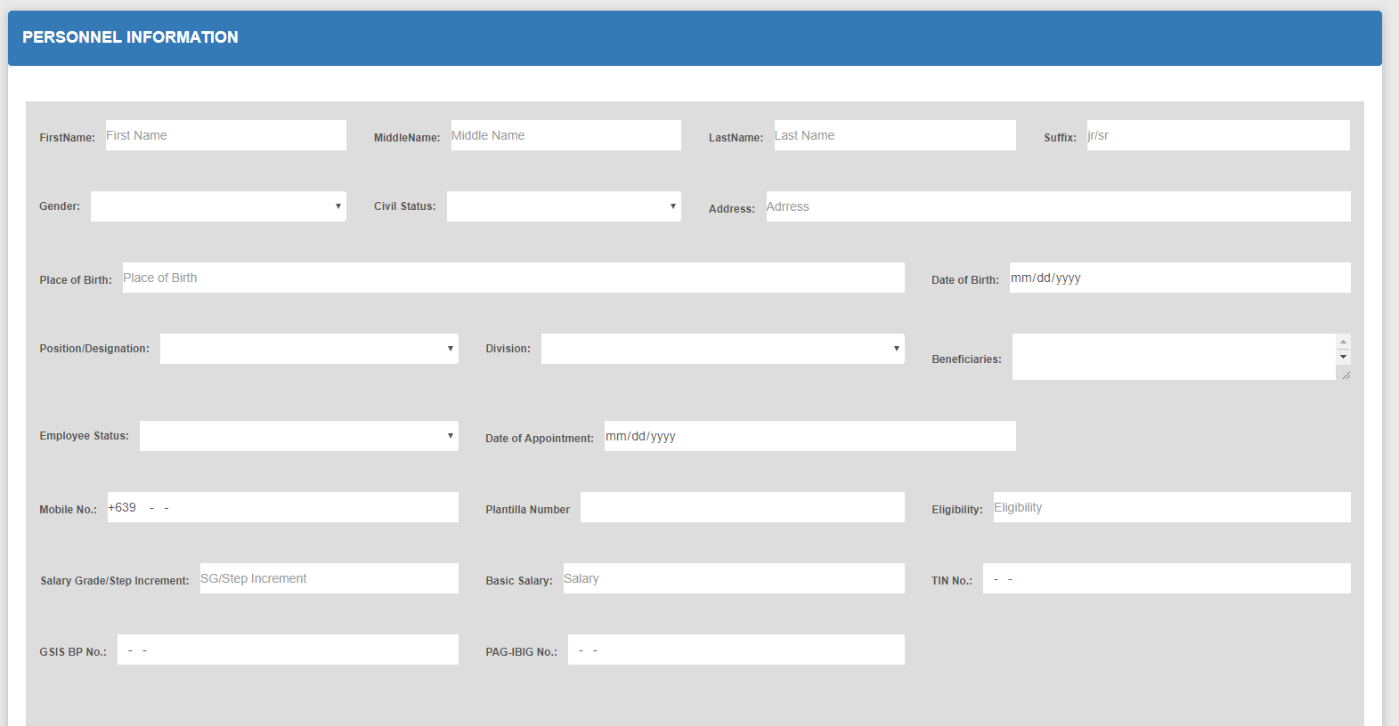

Fill-up Form 1.1

**5.0 Forms , Reporting and Print Outs**

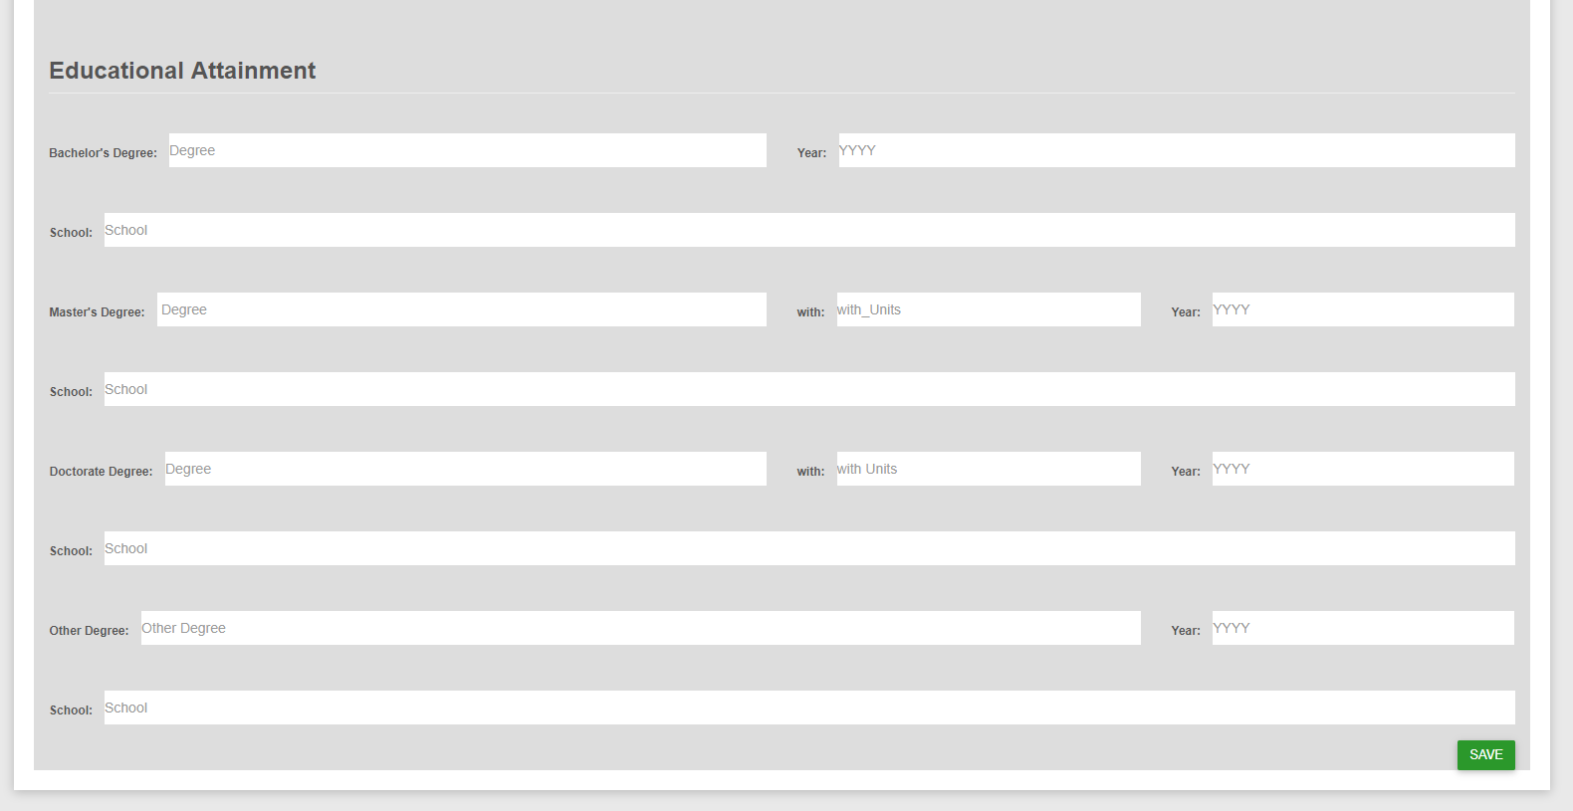

SAVE button

Fill-up Form 1.2

* This is the Fill up form to enter details of the employee/ personnel.

**6.0 Forms , Reporting and Print Outs**

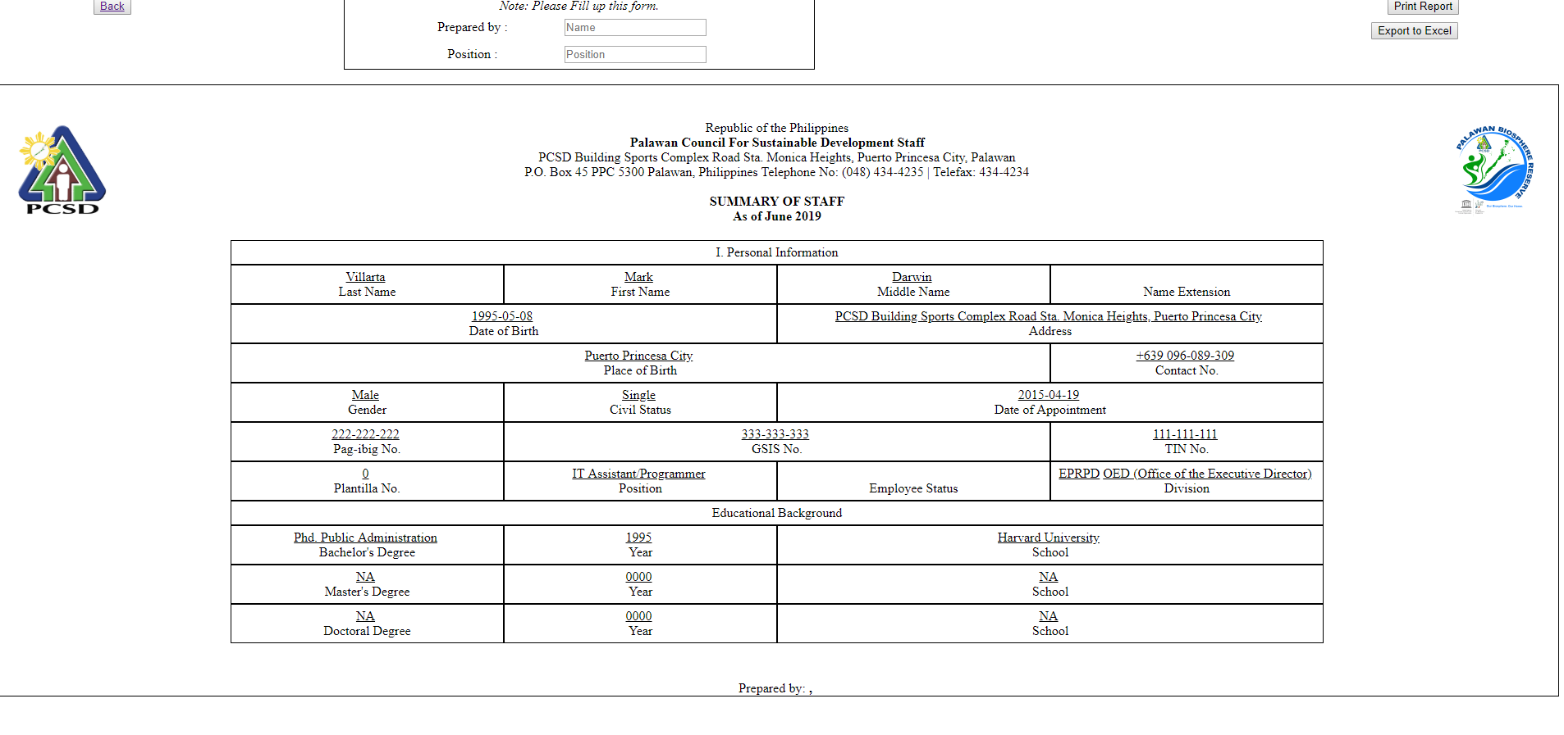

* This will view the summary of information for each employee/ personnel.

**9.0 Log Out (Admin and User)**



Log Out button for logging out.

Log out button informs the Information System that the current user wishes to end the login session.

## Error Messages

Blocked message will appear upon logging in. Immediately contact or visit the Information System Admin.

Table - Support Points of Contact

| Contact | Phone | Email | Role | Responsibility |
| --- | --- | --- | --- | --- |
| Mark Darwin C. Villarta | 09104049265 | elitepro318@gmail.com | IT Staff | Developer |

Appendix A: Glossary

Table 1 – Glossary

| Term | Acronym | Definition |
| --- | --- | --- |
| IS | Information System | is the information and communication technology (ICT) that an organization uses, and also the way in which people interact with this technology in support of business processes. |
| HRIS | Human Resource Information System | Is a computerized database / IS used to input certain or specific employee details or information. Capable of monitoring and storing employee or personnel’s file documents. |
| SD | Sustainable Development | economic development that is conducted without depletion of natural resources. |